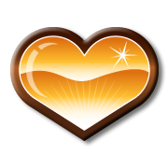

Cow Heart Dissection Name ___________________

Directions: Answer the following questions in complete sentences.

1. Describe the heart. Remember these are observations and statements of fact, NOT opinions. List a minimum of 4 observations

- How do the Atriums and Ventricles differ? How are they are they similar?

- Describe the septum. What it the purpose of the septum?

- Why are the muscles thicker on one side of the heart as compared to the other? Explain. What side are they thicker? What side are they thinner?

- Compare and contrast the VENA CAVA and the AORTA

6. Describe the valves.

7. In five to seven sentences describe why we dissected a cow heart, what did you learn and what were your overall thought about this lesson.

