Transport

The Circulatory System

Function of the Circulatory System
__________________________________________________________________

- Carbon dioxide & other wastes

- Hormones

Parts of the Circulatory System
- Heart
- Blood Vessels
  - ________________________
  - ________________________
  - ________________________
- Blood

The Heart
- Located behind your breastbone, called the sternum, and between your lungs

- _________________________________________

- _________________________________________

- Has four compartments called ______________________
  - The two upper chambers are called the right and left _________
  - The two lower chambers are called the right and left ____________

- The blood flows only in _______direction from an _________________ then from a ventricle into a blood vessel

- A ___________prevents blood from flowing between the two atriums or the two ventricles 4 Chambers

- This wall keeps blood ______________ separate from blood
__________________

- If oxygen-rich blood and oxygen-poor blood were to mix, your body's cells would not get all the oxygen they need

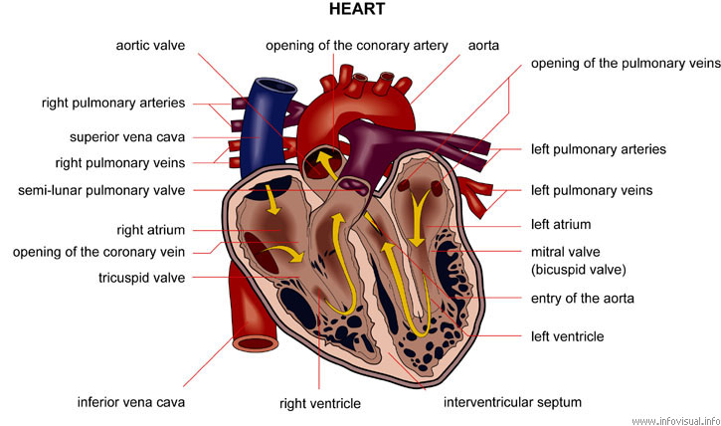

Blood
- Pumped by your heart.

- Travels through thousands of miles of blood vessels

- Carries ______________________________________ products to and from your body cells.

- Made up of __________________________________________________.

Composed ( ) of

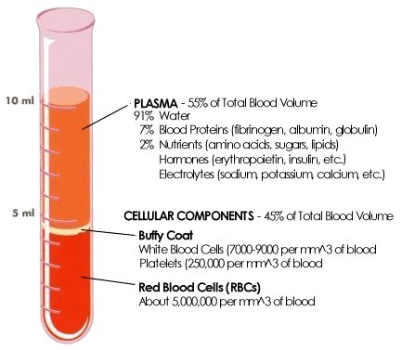

Red Blood Cells
- Red blood cells carry ________________________________________

- Shaped like a bi-concave donut – think jelly donut that is squished in at the middle

- About one billion red Blood cells in a few drops of whole Blood.

- Red Blood cells (RBC’s) live about ________________in our bodies.
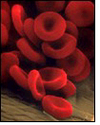
- Frozen red Blood cells can be stored for ten years, and more

White Blood Cells
- __________________________________________________________

- __________________________________________________________

- One drop of Blood can contain from 7,000 to 25,000 white Blood cells.

- Body's primary defense against ______________________________

Platelets
- Platelets -- the _____________________ circulating in the blood that are involved in formation of ________________________

- act as “plugs” in the web of protein that covers a new wound

Plasma
- Plasma is the _________________________of the blood

- About half of your blood is made of ________________

- The plasma carries the blood cells throughout the body
- Plasma is made in the __________________

- Blood itself is a ___________________, but appears to be a __________ because it is carried in suspension in a ____________________________

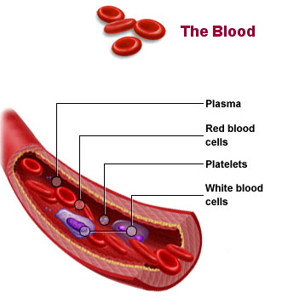

Blood Vessels
- Arteries
- Veins
- Capillaries

Arteries
- Carry blood ___________________ from the heart

- _________________________________________

- Tough on the outside , Smooth on the inside

- Main artery called the ___________________

- Aorta divides and branches and then many smaller arteries

- Each region of your body has system of arteries supplying it with fresh, oxygen-rich blood

Artery Summary:
Picture Key points

Veins
- Carry blood ____________________ the heart

- Receive blood from the ________________________

- Transport __________________________ blood back to the lungs and heart

- Thinner and less muscular than arteries and collapse when empty

- _________________ that keep the blood from flowing backward

Vein Summary:
Picture Key points

Capillaries
- __________________________________________

- Connect ______________________________________

- Capillaries form a network of tiny tubes throughout the body

- Carbon dioxide and other waste products returned to the bloodstream

- _____________________________________

Capillary Summary:
Picture Key points

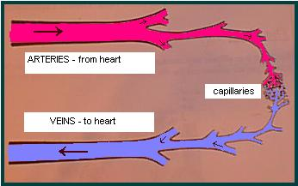

Disorders
- Hypertension (High Blood Pressure)
  - caused by a narrowing of the arterioles resulting in an increased resistance to the flow of blood--increases the strain on the heart
  - Causes:
Age, Stress, Diet, Obesity, Lack of Exercise
Prior family history, Excess sodium intake/renal imbalance
- No cure--may be treated by medication & diet.
- "Silent killer"--millions don't know they have it

B. Angina pectoris
- Chest pain or discomfort that occurs when your heart muscle does not get enough blood, It may also feel like indigestion
- More than 6 million people in the United States have angina.
- People with coronary artery disease or who have had a heart attack are more likely to have angina.

C. Coronary thrombosis
- Also called a myocardial infarction or heart attack.
- blockage, either partial or complete, of the coronary arteries that prevents blood from reaching the heart muscle itself.

