Genetics
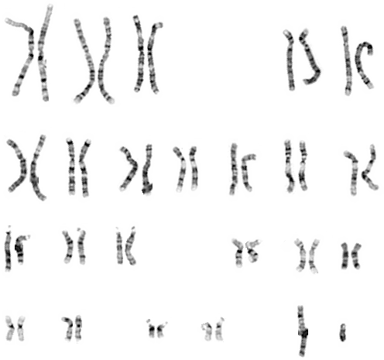

Gregor Mendel - The Father of Modern Genetics

- Austrian monk who studied mathematics and science

- As a boy he could predict the possible types of flowers and fruits that would result from crossbreeding two plants in his father’s garden

- Curiosity about the connection between the color of a pea flower and the type of seed that same plant produced inspired him to begin experimenting with garden peas in 1856.

- Made careful use of scientific methods, which resulted in the first recorded study of how traits pass from one generation to the next.

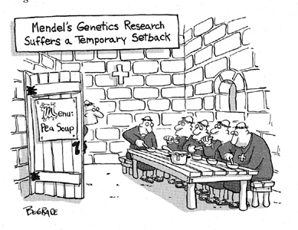

Key Terms and Concepts

Genetics -

Heredity - The passing of traits from parent to offspring

Trait

DNA

- the chemical inside the ___________________ of a cell that carries the genetic instructions for making living organisms

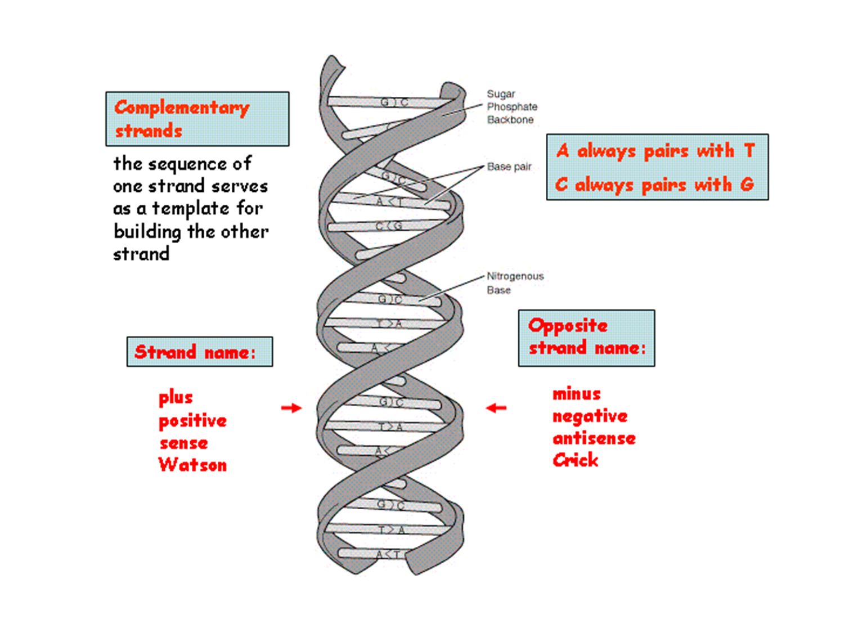

Chromosomes
- A ___________________ is one of the threadlike "packages" of genes and other DNA in the nucleus of a cell.
- ________________ kinds of organisms have ________________ numbers of chromosomes.
- Humans have ____________ of chromosomes, 46 in all: 44 autosomes and two sex chromosomes.
- ___________________ contributes one chromosome to each pair, so children get _____________ of their chromosomes from their mothers and _________________ from their fathers.

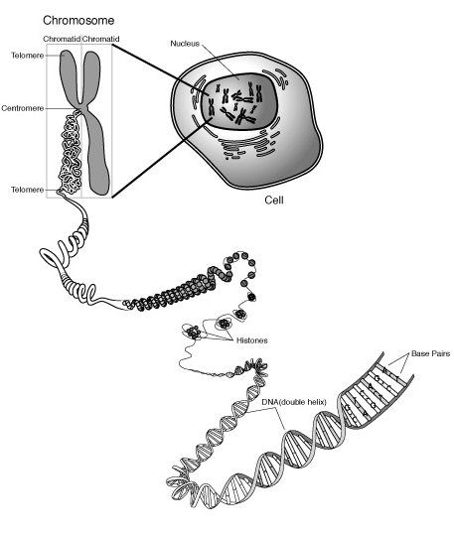

Sex Chromosomes
Females
The gene pair have the ___________________ shape
Females are

Males
The gene pair has a _______________ shape
Males are

Gene

- A ___________________________________unit of heredity passed from parent to offspring.

- Genes are pieces of _________________,

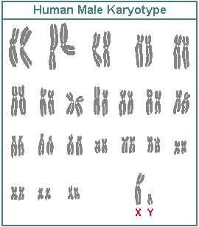

Genome
A genome is the _____________________ contained in an organism or a cell,

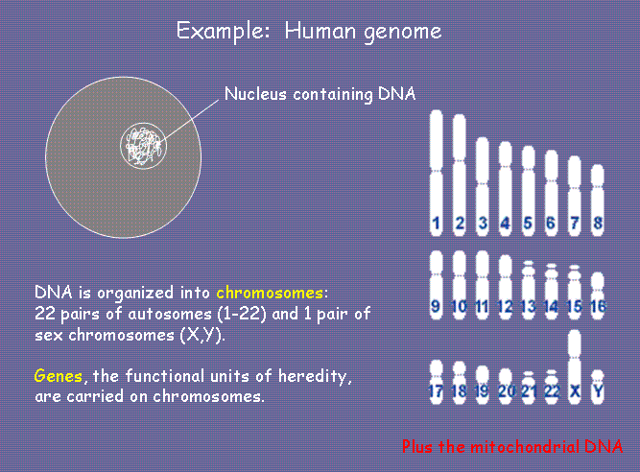

Allele

- Every gene has two or more alternatives
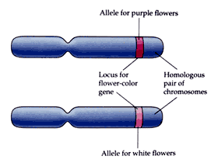
Recessive

- Hidden when the other copy of the gene contains the dominant allele.

Dominant

- Shown by a capital letter

Genotype

Phenotype

Homozygous

- Both alleles [forms of the gene] are the same

- homozygous dominant

- homozygous recessive

Heterozygous

- When alleles occur in different forms

- heterozygous

- heterozygous dominant

Punnett Square

- A tool to predict the probability of certain traits in offspring that shows the different ways alleles can combine

- A way to show ____________________________________________

- A _____________that shows all the possible combinations of alleles that can result when genes are crossed

- Letters stand for dominant and recessive alleles

Parents can come in three different types (genotypes):

 | Homozygous dominant (pure) | Homozygous recessive (pure) | Heterozyous (hybrid)
Genotype

Phenotype

In pea plants, the characteristic for tall is dominant over short. What offspring could result from crossing a homozygous dominant tall pea plant with a homozygous recessive pea plant?

Parent Parent

Possible gametes Possible gametes

Using Punnett Squares Parent

Parent
Results: Potential genotype(s) and percentage: _________________________________________

Potential phenotype(s) and percentage: ________________________________________

1) In pea plants, yellow seed color is dominant over green. What offspring could result from crossing a heterozygous yellow seed with a homozygous recessive pea plant?

Parent

Parent

Results: Potential genotype(s) and percentage: _______________________________________

Potential phenotype(s) and ratio: _____________________________________________

2) In pea plants, long stem length is dominant over short stem length. What offspring could result from crossing two heterozygous long plants?
Parent

Parent

Results: Potential genotype(s) and ratio: ____________________________________________

Potential phenotype(s) and ratio: _____________________________________________

3) In pea plants, the long-stem trait (L) is dominant and the short-stem train (l) is recessive. Two pea plants were crossed, producing seeds that yielded 165 long-stem plants and 54 short-stem plants. The genotypes of the parent plants were most likely (1.) Ll and LL (2.) Ll and Ll (3.) ll and ll (4.) LL and ll

4) In raccoons, a dark face mask is dominant over a bleached face mask. Several crosses were made between raccoons that were heterozygous for dark face mask and raccoons that were homozygous for bleached face mask. What percentage of the offspring would be expected to have a dark face mask?
(1.) 0% (2.) 50% (3.) 75% (4.) 100%

5) In squirrels, the gene for gray fur (G) is dominant over the gene for black fur (g). If 50% of a large litter of squirrels are gray, the parental cross that produced this litter was most likely
(1.) GG x Gg (2.) Gg x gg (3.) GG x GG (4.) gg x gg

