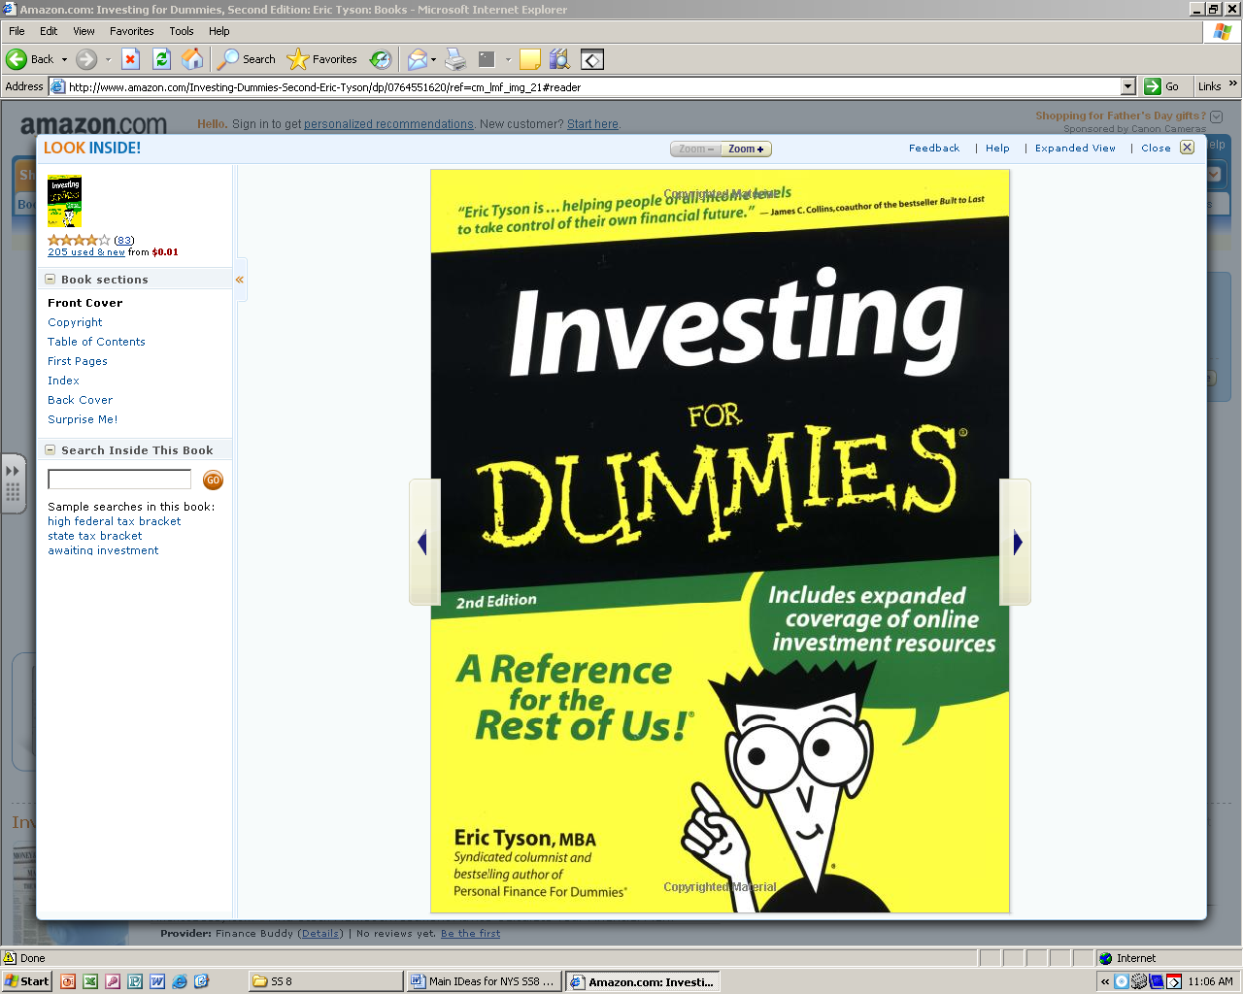
8th Grade Social Studies
NOTES
Created by Mr. Winslow
Midterm review
NOTES

Name _______________________

Period ____________

Civil War and Slavery

- Abolitionists wanted to end slavery. Sojourner Truth, Frederick Douglass, John Brown and Harriet Tubman were abolitionists. Tubman was called a “conductor” on the Underground Railroad helping slaves escape to the north. John Brown organized a slave revolt and broke into an arsenal in Harper’s Ferry, Virginia hoping to steal weapons to give to slaves.

- Harriet Beecher Stowe wrote a book, Uncle Tom’s Cabin, which showed how evil slavery was. People in the North were outraged. This led to the Civil War.

- The North and South had different ways of doing thing (like factories vs. farming). This is called sectionalism. People in the North that did not like the war were called “copperheads.”

- Kansas was called “Bleeding Kansas” because pro-slavery and anti-slavery people both moved there. The Kansas-Nebraska Act said that slavery in any new territory would be decided by popular sovereignty. Popular Sovereignty is when the people vote and decide if they want slavery.

- At first, the Lincoln’s goal was to preserve the Union (bring the country back together). Later he had a goal to end slavery.

- The South had better military leaders and was more familiar with their land. They also thought countries in Europe would help them.

- The North had more resources: weapons, railroads, factories and human resources: men to fight. It was expected they would win quickly, but it really took about 4 years.

- The Southern states started to secede as soon as Abraham Lincoln got elected in 1860. Their president was Jefferson Davis.

- Dred Scott was a slave who sued for freedom because his owner moved to a free state. The Supreme Court said he wasn’t even allowed to sue because he was a slave.

- The first battle of the Civil War was at Fort Sumter in S.C.

- The south won many of the beginning battles, but the turning point was when the North won the Battle of Gettysburg.

- Slaves were treated horribly on the trip over from Africa.

- The Fugitive Slave Law required citizens to capture and return slaves back to their owners if they escaped. Slaves were treated as property.

- The Emancipation Proclamation said that slaves in the south (rebel states that seceded) were free. Lincoln issued this right after the Union won a victory at Antietam. He also hoped European countries would help he north since their had already abolished slavery.

- General Sherman (North = Union) used “total war” and destroyed everything (houses, railroads, civilians, animals,… ) in his path on his trip through Georgia.

- The Civil War ended at Appomattox, Virginia in 1865 when General Lee (South = Confederate) surrendered to General Grant (Union = North). The war showed the the central government was strong.

- The North had a draft law that forced men into fighting in the war unless they were rich enough to pay the fee to get out of fighting.

Reconstruction

- President Lincoln and President Johnson both tried to get the southern states to reenter the Union as quickly as possible. Lincoln’s plan was called the 10% plan and was very lenient according to the Radical Republicans in Congress. They wanted states to approve the 14th amendment as well.

- Even though the 15th amendment was passed, Southern whites tried to limit voting rights of African American men by using poll taxes and literacy tests and the grandfather clause.

- Blacks were segregated and had to use separate facilities (hotels, trains, theatre sections,). This is because of the Jim Crow laws that required segregation. Plessy vs. Ferguson was a Supreme Court case that also said this.

- The white group, the Ku Klux Klan (KKK), also tried to stop blacks from using their rights like the 14th and 15th amendments.

- Many former slaves became sharecroppers and didn’t really make any money at all because they had to give crops back to the owners.

- Three amendments were passed during Reconstruction to give African Americans rights:
  - 13th: officially ended slavery all over the U.S.
  - 14th: gave equal citizenship/protection rights to native born people
  - 15th: gave black men the right to vote

- Carpetbaggers were northern Republicans who moved South during Reconstruction seeking to make money rebuilding the South.

- The Freedmen’s Bureau was created to help the freed slaves get food, clothing, shelter, and an education.

- The Southern states started “black codes” to restrict the rights of the freed slaves and “Jim Crow” laws to separate blacks and whites in public places.

- President Johnson and the Congress did not agree on things. The Congress impeached him.

Westward Expansion

- The major cause of the War with Mexico was the annexation of Texas. Annexation means the U.S. took and added Texas for themselves.

- The Louisiana Purchase added the most territory to the U.S. Thomas Jefferson acquired this land and it doubled the size of the country and gave us control of the port of New Orleans.

- Thousands of people went to California in the 1840s to search for gold. Most did not become rich. They set up boomtowns near where gold was found. After the gold was gone, these towns turned into ghost towns.

- Because thousands of settlers went west, …
  - the U.S. army fought battles with the Indians
  - the buffalo were getting killed
  - Indians were forced to move onto reservations

- Lewis and Clark were sent to map and explore the land in the Louisiana Purchase.

- Manifest Destiny is the belief that God wanted the settlers to move west and own the land (add more territories) all the way to the Pacific Ocean.

- The Trail of Tears was a result of President Jackson’s Indian Removal Act. He was removing all the Indians east of the Mississippi River. Thousands of Cherokee died on this trip from Georgia to Oklahoma.

- People on the Great Plains built sod houses and used barbed wire fences. The weather was difficult (cold winters, hot summers)

- The transcontinental railroad was a huge economic (money) success because people could now trade and do business with others on the other side of the country. The government gave free land to the railroad companies so they could build the railroad.

- The Homestead Act gave 160 free acres of land in the Great Plains to people who would farm it for 5 years to encourage settlement in the west and make it grow. They did pay a $10 filing fee.

Immigration

- Irish people were discriminated because of their religion.

- The poem by Emma Lazarus on the Statue of Liberty welcomes immigrants to the U.S. (“Give me your tired, your poor, …”)

- Immigrants moved into large cities because there were many factory jobs for unskilled people. They lived in districts near others who spoke the same ethnic language because not all of them knew English.

- Nativists used the quota system in the 1920s to reduce and limit the number of immigrants from certain countries in Asia. Example: Chinese Exclusion Act. Before that the U.S. wanted immigrants so they could work in factories.

- The largest numbers of immigrants came from North and Western Europe like Great Britain and Ireland. Then the “new” immigrants came from Southern and Eastern Europe.

- Ellis Island was opened to process the immigrants into the U.S. from Europe.

- “Old” immigrants were prejudiced against the newer immigrants because they had different cultures (languages, religions, clothes, customs, illiterate, …)

- Nativists are people born in the U.S. who didn’t like immigrants. They thought they would be taking jobs away from people born in this country by working for cheaper wages.

- All the many different types of immigrants have led to cultural diversity in the US.

- Immigrants lived in crowded apartment building in the cities called tenements. They moved to the cities because there were jobs in the factories.

- Immigrants also got help from settlement houses like the Hull House that help fight against unfair labor practices so they could get decent jobs.

- Labor Unions also tried to help get safer working conditions like better wages and fewer hours. They fight the bosses to protect workers’ rights.

Industrial Revolution

  - Before the Industrial Revolution, factories were powered by water. Railroads were probably the biggest reason industrialization grew!

  - The cotton gin was a faster way to separate the seeds from the cotton fibers.

  - The Industrial Revolution caused goods to be made more by machines than by hand. More people moved to cities to work in these factories.

  - The prices went down shortly after factories started mass-producing goods. An example of this is Henry Ford’s assembly line which made a huge number of Model T cars quickly and cheaply.

  - People buy stock because they want to share in any profit the corporation (huge company) makes.

  - Inventions like light bulb (Thomas Edison) and the telephone (Alexander Graham Bell) happened during this time.

  - The Industrial Revolution made cities grow fast (urbanization).

  - Industrialization has caused the environment to be polluted by businesses, cities to grow, produce more agricultural products, and more middle class people.

  - Henry Bessemer invented a new way to make steel stronger and faster. Thomas Edison invented the light bulb. Alexander Graham Bell invented the telephone.

  - Ruthless big business monopoly owners were called “robber barons” and dominated certain industries trying to get rid of competition. They were ruthless and did whatever they needed to increase their profits.
  - Andrew Carnegie = steel
  - John D. Rockefeller = oil
  - JP Morgan = banking

They took out the competition!

  - Railroads were probably the biggest reason industrialization grew!

  - Mark Twain called this time period the Gilded Age. This is because just like something can be covered with a thin layer of gold, it represented the thin layer of very rich people in the US that had power over all the poor people underneath them.
Progressive Era

- Joseph Pulitzer used yellow journalism to write exaggerated stories in the newspapers.

- Antitrust laws like the Sherman Antitrust Act was designed to regulate (control) the power of big businesses like monopolies from growing. President Theodore Roosevelt was called a “trustbuster” because he tried to break up the bad monopolies.

- Muckrakers wrote articles in books and newspapers about the problems they saw in society.

- Upton Sinclair wrote a book called The Jungle which exposed problems in the meat packing industry (rats, poop, …) so things would change in the future. This led to the Meat Inspection Act and the Pure Food and Drug Act.

- Jacob Riis took photos and wrote a book called How the Other Half Lives to show how bad the urban slums were for poor immigrant people.

- This time period tried to fix problems caused by big business, protect consumers , and the get rights for people.

- People got more involved in government with ideas such as initiatives, referendums, and recalls.

- People were given jobs they weren’t qualified for because they supported and voted for certain candidates. This ended when the Civil Service System was created and people had to take a test to show they were qualified for certain jobs.

- Women like Susan B. Anthony and Elizabeth Cady Stanton fought for women’s suffrage in the early 1920s and tried to pass an amendment to let women vote.

