Science 8 Name ________
Date __________ Period _______

Review Sheet “Earth Science”

- look at the review sheet for “Early Astronomy, Rotation, Revolution, Seasons, Planets, and Moon Phases” as well!!

- Earth’s rotation makes the sun appear to rise in the east

- Moon phases:

- happens every 3 days
- takes about 28 days total (1 month)
- takes 2 weeks from new to full moons
- waning means getting smaller
- waxing means getting bigger
- we see the moon because the sun’s light is reflected off it

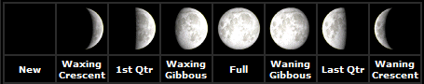

- Tides:

- The rising and falling of the water on the coastlines
- Mostly caused by the moon’s gravity
- There are 2 high and 2 low tides every day due to the revolution of the moon around Earth
- There are 12 hours between each high tide and 6 hours between every low and high tide
- The water on earth closest to the moon is the high tide
- The water farthest away from the moon is also high tide
- The water on the sides would have the low tides

- Special Tides:
- spring tides happen twice a month
- the high tides are extra high and the low tides are extra low
- happens during new moon and full moon
- when sun-moon-earth are in a straight line

- neap tides happen twice a month
- the high tides are extra low and the low tides are extra high
- happens during first and third quarter
- when sun-earth-moon are in a 90º angle

- Other objects in the solar system:

- Comets are leftover ice, rock, and dust
- Comets have tails when closest to the sun
- Asteroids are found between Mars and Jupiter
- Meteoroids that hit Earth are called meteorites

