

**Welcome to the Lyons CSD Permanent Orienteering Course!**

What is orienteering?

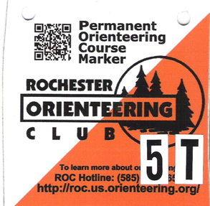

Orienteering is an activity that involves using a map to locate control flags at selected points around our campus. It’s a great way to get active outdoors! Permanent course controls are orange and white, 4” plastic squares. The magenta colored circles on the map show the general location of the control. The clues below give more precise information. Each control is numbered and has a code letter or symbol. When you find a control, write the code letter in the corresponding numbered box on your punch card. When you have found at least **8** of the 20 controls, submit your punch card to the Wellness Committee. You may visit the controls in any order and/or over several visits around campus. **Please turn in your punch card to the Wellness Committee: Pam Lockwood, Jill Harper, or Robin Cinelli, by May 23, 2019, to be eligible for the $10 Wegmans gift card!** Please indicate on the back of the punch card how many students went with you, if any.

Directions and hints:

1. Print off this file and before starting, familiarize yourself with your map and make a plan!

2. Begin with the easy controls, those that are near major trails or obvious features. If you get disoriented, return to the last point that is familiar.

3. Keep your map turned (oriented) by matching features on the map with features on the ground or to the north by using a compass. You can fold the map and hold it with your thumb firmly at your current location. You'll avoid having to relocate every time you look back at your map.

4. Be sure to bring a pen or pencil.

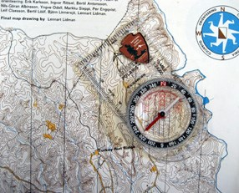5. A compass is not necessary but may be helpful in locating north. An inexpensive compass ($10) with a rotating base plate and a needle that settles relatively fast is fine for beginners. A compass may be borrowed from Don Winslow in the MSHS, Room 142.

6. Man-made and vegetation features shown on the map may have changed since the printing of the map.

7. If any of the controls are missing or damaged, please note that on the punch card.

8. Wear appropriate clothing/footwear for the conditions. Some of the trails in the northeast section of the map have muddy sections. You can find 8 of the controls without having to visit this section. Wearing long pants is suggested as there are some areas with thorns and branches that stick out. Bug repellent is also a good idea.

9. Have fun!

**Control Clues**

**Easy**

1. Fence

3. Fence

7. Fence

8. Bridge

14. Building/Wall

15. Building

16. Sign

17. Bridge

19. Bushes

**Medium**

2. Tree

4. Stump

5. Knoll (small hill)

6. Ditch

9. Trail Bend

13. Trail Junction

18. Structure/Stream

20. Tree

**Difficult**

10. Small boulder

11. Tree

12. Ruin

More Information:

If you enjoyed your experience and want to do more orienteering in different places, contact the Rochester Orienteering Club at 585-310-4ROC or contact Don Winslow at the MS/HS, Room 142, Phone #2142. The club sponsors events in other parks and forests throughout the year including canoe, nighttime, bike and cross country ski orienteering events. Permanent Course Maps of Letchworth State Park, Mendon Ponds Park, Webster Park, and Durand Eastman Park are also available for purchase. Visit the club website at <https://roc.us.orienteering.org>

