Introduction To Biology

Organization of Data

Scientific Method

Life Process

Vocabulary

Introduction to Biology

**Organization and Interpretation of Data**

A scientist’s observations need to be recorded in an ____________ manner. Two common methods used to record observations are the ________________ and _____________________

**Data table:**

The data table is used to record ________________ data.

The information is organized by arranging observations into columns with _______________________.

**Bar Graph** (Histogram): A bar graph allows a scientist to ____________________ data.

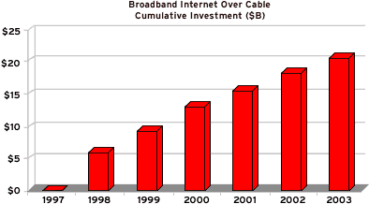

**Line Graph**: A line graph is used to show ___________________________ between two or more variables

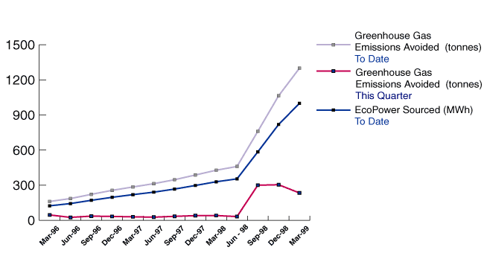

**Independent variable**: is placed on the _________________________________________________________

Independent variables are usually the variables that the scientist __________________________

Ex. ____________________________________

**Dependent variable**: is placed on _____________________________________________

Dependent variables depend on the changes in the independent variable.

**The Scientific Method**

The technique used by scientists to ______________________ and gain ___________________________.

The Scientific Method is a process of _________________thinking.

Steps of the scientific method:

1. Problem

2. ________________________________________

3. Experimentation

4. ________________________________________

5. Conclusions

**Problem:**

A problem must be _______________________________

It is a question for which a scientist is trying to _____________________________

Ex. Will a plant grow in complete darkness?

**Hypothesis:**

An ______________________________________________ about the answer to the problem.

The hypothesis is based on information which has been learned about the problem.

It is your _____________________________ to a possible answer to the problem

Ex. I think that...

**Experimentation:**

**S**et up a ________________________________________ that will test the hypothesis or claim

_________________________________________: an experiment which tests only one factor.

Ex. 2 of the same species plant, one grown in complete darkness, and the other grown in regular light

**Variable:**

Is the factor to be _______________________

Ex. amount of light

**Independent Variable**

* something that is _________________ by the scientist
* ____________________ by the scientist
* What is tested
* What is _____________________________

**Dependent Variable**

* + something that might be _____________________ by the ____________________ in the independent variable
  + Changes because of the ____________________
  + ________________________________
  + What is observed
  + What is measured
  + The __________________________ collected during the investigation

**Controlled Variable / Control**

* a variable that is _________________changed
* Also called constants
* Allow for a “_________________________________”
* An exact duplicate experiment without the variable.

Identify the variables in this investigation:

Students of different ages were given the same jigsaw puzzle to put together. They were timed to see how long it took to finish the puzzle

Independent Variable ______________________________________________

Dependent Variable ________________________________________________

Control(s) ________________________________________________________

Draw a Data Table

An investigation was done with an electromagnetic system made from a battery and wire wrapped around a nail. Different sizes of nails were used. The number of paper clips the electromagnet could pick up was measured.

Independent Variable ______________________________________________

Dependent Variable ________________________________________________

Control(s) ________________________________________________________

Draw a Data Table

**Observations / Claims:**

* + Measurements, notes, records of things seen, heard, felt, during the experiment.
  + Usually, observations must be made using __________________________________________

**Conclusions:**

* + Explanations of the problem based on the observations. True conclusions must be backed up by _________________________ and _______________________________ data from the experiments____________________________________

Example:

**Scientific law**:

Scientific facts based on experiments which have been done ___________________________.

Ex: ___________________________

**Theories**

________________ possible explanations of complex problems. Theories can ________________.

Ex: Theory of Evolution

**Life Process**

**Life Functions**

There is not simple definition for life. However many characteristics of living things have been defined.

**Life Processes**

1. **Transport**: ________________________________________________________ of materials within an organism. (Circulation)
2. **Excretion**: __________________________________ that the organism itself has made.

**3. Nutrition:** All activities that an organism does to get materials from the environment and prepare them for use.

**Reasons for Nutrition:**

**Energy:** all living things need ________________________

**Raw materials**: all living things need raw materials for _______________________________________________

**Steps in Nutrition:**

**Ingestion:** ________________________________________________ from the environment

**Digestion:** ____________________ of food materials into ____________ forms that an organism can use

**Egestion:** ___________________________________________________________ (feces)

**Types of nutrition**

**_____________________:** (self feeder) an organism that can synthesize its own food (plants)

**____________________:** (other eater) an organism that cannot synthesize its own food

4. **Growth:** Using the products of __________________________to increase cell size or number

5. **Respiration:** ____________________ process by which an organism obtains ___________________ from food materials in order to maintain life functions.

Respiration in this case refers to *_______________________,* not breathing

6. **Regulation:** The __________________________ of the activities of an organism and the response to its environment using nerve impulses or hormones

7. **Reproduction:** The _____________________________________. This must occur in order for a species to survive, however, an individual organism does not need to reproduce in order to survive.

8. **Synthesis:** The process by which an organism __________________ large molecules from smaller ones

All of the chemical reactions responsible for the life functions, occurring in an organism are known as that organism’s ____________________________________…

The goal of these chemical reactions and the life functions is to maintain “_______________________” or a “Same State”.

Keeping a constant internal environment.

Examples:

* + Body temp remains relatively constant (37 degrees C)
  + The amount of glucose (sugar) in the blood needs to be within a certain range.

**Key Vocabulary**

**MEASURING**

1. Length: the distance from point to point
2. Mass: describes an amount of matter
3. Volume: describe the space occupied by matter
4. Temperature: measures the average kinetic energy in matter
5. Gram: a small amount of mass used to measure small objects
6. Kilogram: a large amount of mass used to measure large objects
7. Meter: the basic unit of length
8. Centimeter: a small unit of measurement used for small distances
9. Kilometer: a large unit of measurement used for large distances
10. Liter: the basic unit of volume
11. Graduated cylinder: an instrument used to measure volume
12. Celsius: the Metric system for recording temperature
13. Fahrenheit: the English system for recording temperature

**GRAPHING AND THE SCIENTIFIC METHOD**

14)  Assumption: a possibility based on observations

15)  Bias: tendency to favor, prejudice

16)   Conclusion: decision about an experiment based on results and hypothesis

17)   Controlled Experiment: all variables are the same except for the tested one

18)   Data: collected results from tests during experiments

19)  Variable: one factor different from the conditions found in the control

20)  Dependent variable: what is measured because of the independent variable

21)  Independent variable: the factor that influences the dependent variable

22)   Evidence: support for something that is true or not true

23)  Experiment: series of tests to support or refute a hypothesis

24)   Hypothesis: an educated guess based on available information

25)   Inference: a conclusion based on observations

26)   Law: a fact based on proven evidence

27)   Model: representation to explain a process or structure

28)   Observation: information collected with the senses

29)   Research Plan: initial stage of an experiment

30)   Testing: to try something based on research

31)   Theory: accepted as true that may or may not be true

32)  Control: standard of comparison