BioChemistry

Basic Chemistry

Acids / Bases

Organic Molecules

Carbohydrates

Lipids

Proteins

Nucleic Acids

Hydrolysis

Dehydration Synthesis

**Atoms**

* The _____________________ unit of matter
* Composed of three subunits
  + **Protons** – _____________ charged, located in the ______________, and weigh 1 amu.
  + **Neutron** – _________________, located in the nucleus and weigh 1amu.
  + **Electrons** – negatively charged, located in ___________________ around the nucleus, very little mass.

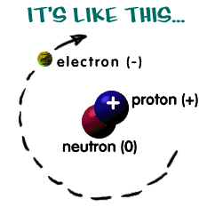

* Atoms interact through the __________________ or ____________________ of electrons.
* These interactions are called ___________________________________**.**

**Chemical Bonding**

* **Covalent bonding** – Chemical bonding between atoms that result from the ___________________of electrons.
* **Ionic bonding** – chemical bonding between atoms that result in the ________________of electrons and the formation of ions (________________).

**Chemical reactions**

* ________________________ between elements and or compounds

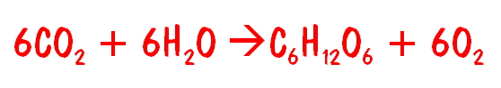

_________________________ ________________________

**Acid and Bases**

* _______________ – a scale used to measure the strength of an acid or base.
* pH measures the ______________ or _____________________
* Specifically the concentration of H+ ions

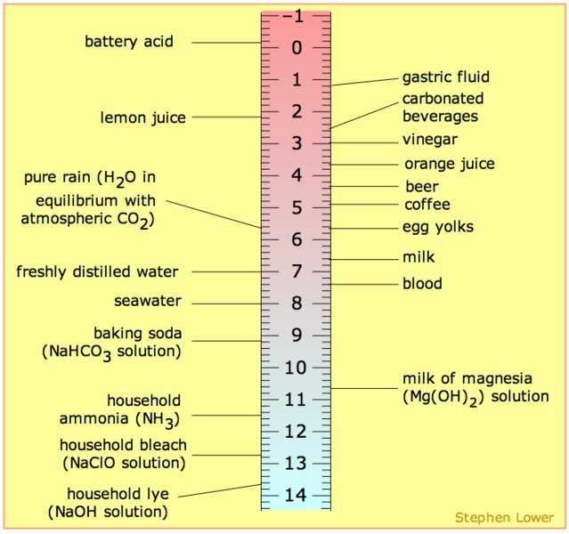

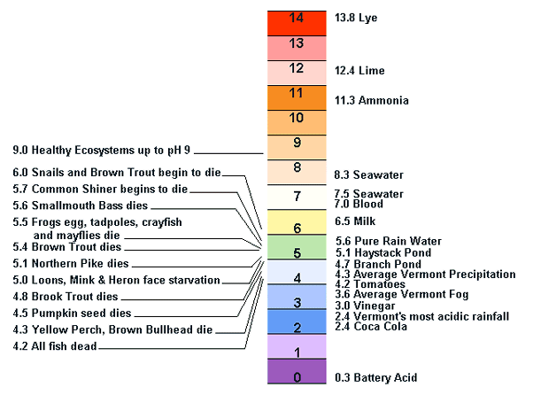

**Properties of Acids**

* 1. ________________________
  2. Have pH less than __________________
  3. React with indicators, producing a variety of colors, depending on the indicator and the acid used
  4. React with bases to produce ______________ and a _________________
  5. Lemon juice, pepsin, vinegar

**Properties of Bases**

* 1. _____________________________
  2. Have a pH __________________ than ______________________
  3. Feel _______________________ on your skin
  4. React with indicators to produce a variety of colors, depending on the indicator and the base used.
  5. React with acids, producing water and a salt
  6. Baking soda, ammonia, trypsin

**Neutral Substances**

* Have a pH _________________ to 7
* Common neutral substance – _______________________
* Substances with a pH of 7 are neutral, neither acid nor base.
* Pure Water has a pH of 7

**Indicators**

* Used to find out the pH of solutions
* Changes color depending on how acidic or basic the solution is.
* Many natural substances can act as indicators, including cabbage juice from a red cabbage and the juice of blueberries.

Blue Litmus Paper

Turns red – _______________

Stays blue – ______________

Red Litmus paper

turns blue – _______________

stays red – _______________

Neutral Substances

Leave red litmus red, blue paper stays blue

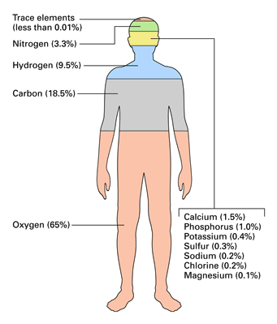

**Biochemistry**

**Organic Chemistry**

The elements most common to living things are:

_____________________

_____________________

_____________________

_____________________

**Organic compounds** – compounds that contain both _______________ and _______________

* + - Almost always form molecules and are covalently bonded
    - These are the molecules that are associated with _____________
    - A compound made by a _____________organism

**Inorganic compounds** – compounds that ___________ contain both C and H.

Examples – ___________________________________

_________________ organic and inorganic substances are necessary for life.

* + E.g. H2O, O2, C6H12O6

**Macronutrients**____________________ required in ______________ amounts by living things

**Molecules of Life**

Put ______________________ together in different ways to build living organisms

What are bodies made of?

* + ___________________________
    - sugars & starches
  + proteins
  + _________________
  + nucleic acids
    - ________________

Why do we eat?

* We eat to take in more of these chemicals
  + - ______________________________
    - to make more of us (cells)
    - for growth
    - for repair
  + Food to make energy
    - _____________
    - to make ______________ =

Water

* + ___________ of your body is H2O
  + water is ________________
    - doesn’t contain carbon

Rest of you is made of _______________ molecules

* + __________________ molecules
    - carbohydrates
    - proteins
    - fats
    - nucleic acids

_________________

A single subunit. Many monomers can be joined to make larger molecules.

_____________

A long chain of many (3 or more) monomers.

FOUR MAJOR ORGANIC COMPOUNDS

|  |  |
| --- | --- |
| Compound - | Subunit - |
|  |  |
|  |  |
|  |  |
|  |  |
|  |  |

**Carbohydrates**

* + Organic Compound

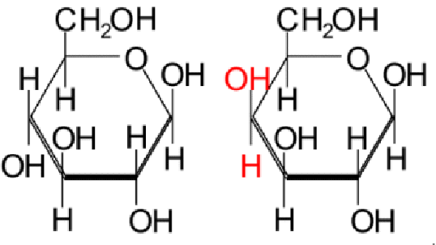

* + Main source of energy for all activities
    - _________________
    - energy storage
    - _________________
      * cell wall in plants
  + Formed from C, H, and O in a 2:1 ratio
  + Building block molecules

**Monosaccharides**

* The smallest unit of carbohydrate - ___________________
* Most monosaccharides have the chemical formula _______________________
* Monosaccharides can be connected together by the process of dehydration synthesis.
* The ___________________________ of carbohydrates, the ______________ unit of carbohydrate

**Disaccharides**

* Two monosaccharides connected
* Connected by __________________________________________
* Most common examples are ______________________

**Polysaccharides**

* __________________________________________
* _______________________or more monosaccharides connected
  + large carbohydrates
    - ___________________
      * energy storage in plants
    - ___________________
      * energy storage in animals
      * in liver & muscles
      * chitin
      * structure in arthropods & fungi
      * exoskeleton

Draw a Disaccharide

Draw a monosaccharide

Draw a Polysaccharide

Carbohydrates - Can you do This?

* List several examples of carbohydrates?
* Explain the difference between a monosaccharide, dissaccharide and polysaccharide?
* List three examples of polysaccharides and state their function?

**Lipids**

________________________________

Functions:

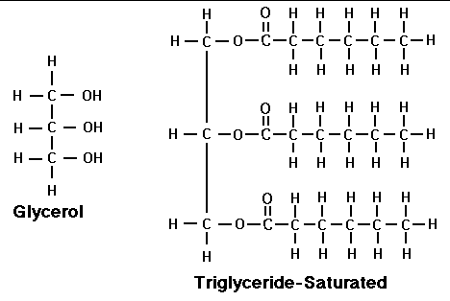

* + Reserve energy supply
  + ______________________
  + Insulation
  + _______________________
  + Hormones

Examples

* + _____________
  + _____________
  + waxes
    - hormones sex hormones
      * testosterone _____________
      * estrogen ________________

Tend to be large molecules

Structure:

* + Contain Carbon, Hydrogen, and Oxygen
  + Hydrogen and Oxygen **______________** in a 2:1 ratio
  + Most lipids contain two basic parts: a ______________ and a ______________

Not a chain (polymer) = just a __________________ molecule

* These molecules are _________________ (afraid of water); they will not mix with water

Saturated fats

* ___________________________
  + solid at room temperature
* Limit the amount in your diet
  + ______________________________
  + deposits in arteries

Unsaturated fats

* ____________________________________
  + liquid at room   
    temperature
    - the fat molecules don’t stack tightly together
* Better choice in your diet

Other lipids in biology

Cholesterol

* + good molecule in ___________________________
  + make hormones from it
    - including sex hormones
  + but too much cholesterol in blood may lead to heart disease

Draw a Lipid

Lipids – Can You do This

* list some examples of lipids and some basic functions of these.
* state the basic functions of phospholipids and steroids.

**Proteins**

**_________________________________**

Many, many functions

* + - ___________________________
      * signals from one body system to another
      * insulin
    - movement
      * _____________________
    - __________________________
      * protect against germs
    - enzymes
      * ________________________

Examples of Proteins

* ________________
* __________________________________
* collagen, keratin
* ____________
* digestive enzyme in stomach
* insulin
  + - * hormone that controls blood sugar levels

Monomer

Structure:

* + There are __________________ different amino acids
  + Amino acids can be connected together by ____________________ synthesis
  + **Dipeptide**: _______________amino acids connected together
  + **Polypeptide**_________________ amino acids connected together
  + Dipeptides and polypeptides can be broken down by _________________

Each amino acid is different

* + some “like” water & dissolve in it- ____________________
  + some “fear” water & separate from it - ________________

Polypeptide (protein)

* + ____________ protein molecules linked together in very long _____________.
  + As the protein forms, they ___________ the chain. This folding makes each protein unique
  + ______________________________________________

Draw a Polypeptide

For proteins: _________________ matters*!*

* Proteins ____________________________ into 3-D shape
  + that’s what happens in the cell!
* _______________________________________________________
* Proteins do their jobs, because of their _____________________
* Unfolding a protein ________________ its shape
  + wrong shape = _______________________________
  + unfolding proteins = ____________________________
    - temperature
    - pH (acidity)

Water-fearing amino acids

* Hydrophobic
  + ________________________________________
  + try to get away from water in cell
    - the protein folds

Water-loving amino acids

* Hydrophillic
  + ____________________________
  + try to stay in water in cell
    - the protein folds

Proteins – can you do this?

* list the major functions of proteins in the body.
* recognize that proteins are composed of amino acid subunits.
* explain what is meant by a dipeptide and a polypeptide.
* list three examples of polypeptides.
* explain in a sentence or two why there are so many possible kinds of proteins.

NUCLEIC ACIDS



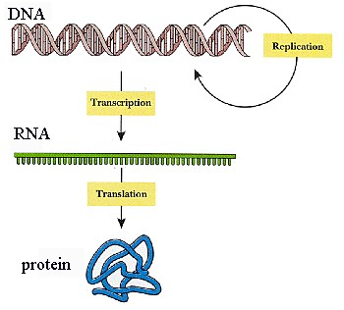



Elements

* Carbon
* Hydrogen
* Oxygen
* Nitrogen
* Phosphorous

Monomer

* __________________________

Function

* ____________________________ for:
  + Traits
  + Protein synthesis
  + Enzymes

DNA (deoxyribonucleic acid)

* often called the _____________________________ for life.
* Carries the complete _______________________ what makes you who you are
* ______________________ (looks like a twisted coil of a ladder); composed of

repeating subunits called ______________________________

RNA (ribonucleic acid)

* _______________________ ( ½ of the twisted ladder)
* Composed of repeating subunits called __________________________
* Major player in creation of _________________________ (when we get to genetics)

Draw RNA

Draw DNA

Nucleic Acids – can you do this?

explain the basic difference in structure and function between DNA and RNA

Building large molecules of life

* Chain together smaller molecules
  + building block molecules = ____________________________
  + Big molecules built from little molecules - ___________________
* ______________________ = building blocks
* ____________________________ = polymers

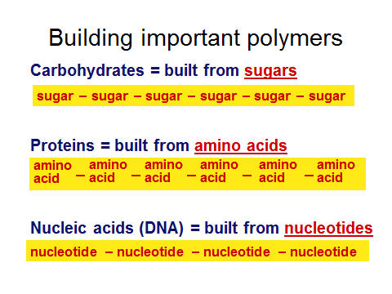

Synthesis

* + ______________________ bigger molecules from smaller molecules
  + building cells & bodies
    - _____________________
    - _____________________
    - reproduction

Digestion

* + _____________________________________________
  + getting raw materials
    - for synthesis & growth
  + making _________________________________________
    - for synthesis, growth & everyday functions

Major Reactions in Living Things

Dehydration Synthesis

* Bring together while losing ________________________
* ______________ of large molecules, often used for storage, from smaller molecules.
* Three or more smaller molecules are combined to form 1 larger molecule and _________
* ______________ is a by-product of this process

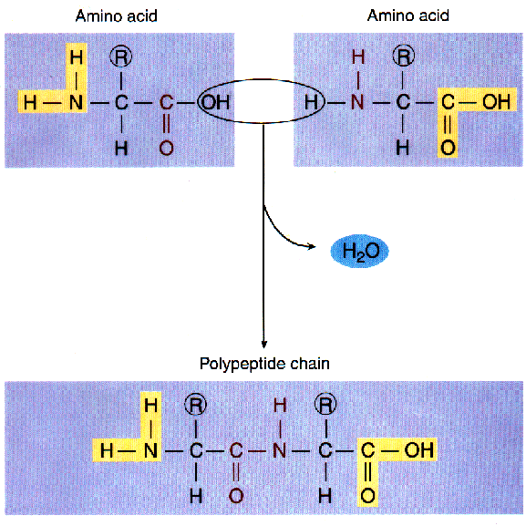

Hydrolysis

* + Use water to ______________________________
  + Break down of large molecules into smaller, more easily __________________ molecules.
  + During Hydrolysis ______________________________ are broken apart with water to form smaller molecules

|  |  |  |  |  |  |
| --- | --- | --- | --- | --- | --- |
| Organic Compound / Picture | Monomer(s) | Element | Ratio of Elements | Uses | Examples |
|  |  |  |  |  |  |
|  |  |  |  |  |  |
|  |  |  |  |  |  |
|  |  |  |  |  |  |
|  |  |  |  |  |  |

Atom – smallest unit of matter

Element- substances made form one type of atom

Molecule- atoms held together by covalent bonds

Compound- 2 or more kinds of atoms combined in different proportions

Covalent bond- sharing of electrons

Ionic bond- transfer of electrons

Acid- makes H3O+ ions in water

Base- makes OH- ions in water

pH- measure of acidity and alkalinity; 1-14

Inorganic compound- molecule which does contains both C and H

Organic compound- molecule which contains both C and H

Building blocks- simple molecules which can be joined to form large ones

Monomer- building blocks of polymers; a single molecule

Polymer- molecules containing a chain of repeating units

Organic macromolecules- large molecules used to perform life functions

Carbohydrates- organic molecule containing C,H,O: H:O ratio of 2:1

Monosaccharide- simplest type of carbohydrate, simple sugar

Disaccharide- simple sugar containing 2 rings

Polysaccharide- long chain of simple sugars

Starch- polysaccharide found in plants and used to store energy

Glycogen- polysaccharide found in animals and used to store energy

Glucose- simple sugar, C6H12O6

Lipids- macromolecule made from glycerol and 3 fatty acids

Fat- macromolecule made from glycerol and 3 fatty acids

Saturated fat- fatty acid with only single bonds between the carbons

Unsaturated fat- fatty acid with one of more single bonds between the carbons

Protein- macromolecule made of amino acids

Amino acid/ peptide- basic building blocks of proteins

Peptide bond- chemical bond joining two amino acids

Dipeptide- 2 amino acids joined by a peptide bond

Polypeptide- long chain of amino acids

Nucleic acids- macromolecule which carry genetic info

DNA- nucleic acids which carry genetic info

RNA- nucleic acids which help with protein synthesis

Nucleotides- building blocks of nucleic acids containing a nitrogenous base, C,H,O,and P

Dehydration synthesis- combining small molecules to make larger one with the loss of water

Hydrolysis- breakdown of a large molecule with by adding water

Index Card Questions

1. pH measures what?
2. What is the pH of a strong base?
3. Mixing an acid with a base is what type of reaction?
4. A substance becomes more _____ as pH increases?
5. A substance becomes more _____ as pH decreases?
6. What is an indicator?
7. HCl is a strong what?
8. What is an acid?
9. What number represents neutral on the pH scale?
10. What is the pH of a strong acid?
11. What is a base?
12. How many times more acidic is a substance with a pH of 2 that a pH of 4?
13. What are the products of mixing an acid and a base?
14. Give three common examples of lipids.
15. What are the 4 major macromolecules found in living things?
16. What is the function of both starch and glycogen?
17. What is the ration of carbon: hydrogen: oxygen in a sugar?
18. What are two major functions of proteins?
19. What are the basic building blocks of proteins?
20. What are 4 examples of polysaccharides?
21. What are the 4 subgroups that make up one amino acid?
22. What are the two types of nucleic acids?
23. Why is it possible to make a very large number of different proteins?
24. How do amino acids differ in basic structure?
25. State the function of each type of nucleic acid.
26. How can you recognize a carbohydrate molecule?
27. What 2 building blocks are used to make lipids?
28. What are 2 examples of fatty acids and how are they different?
29. What are the monomer building blocks of carbohydrates
30. Which 2 elements are always found in organic compounds?
31. What elements are always found in amino acids and proteins?
32. What is the difference between monomers and polymers?
33. Give 2 functions of lipids?
34. What are the basic building blocks of nucleic acids?

Synthesis and Hydrolysis

1. What are the products of combining 2 simple sugars?
2. What process is responsible for protein digestion?
3. What process combines 2 amino acids?
4. What is formed when 2 amino acids are combined?
5. What process breaks does a disaccharide into to monosaccharides?
6. What needs to be added to breakdown a protein into an amino acid?
7. What are the products of combining glycerol and 3 fatty acids?
8. What process is responsible for the formation of lipids?
9. What is dehydration synthesis? What type of molecules are produced?
10. What does hydrolysis mean? What is produced?
11. The breakdown of a fat is accomplished by what type of reaction?
12. What process combines sugars to form polysaccharides?